# 

# Dr David H. DEJOUR M.D.

Head Director Lyon-Ortho-Clinic

President of ESSKA 2018 - 2020

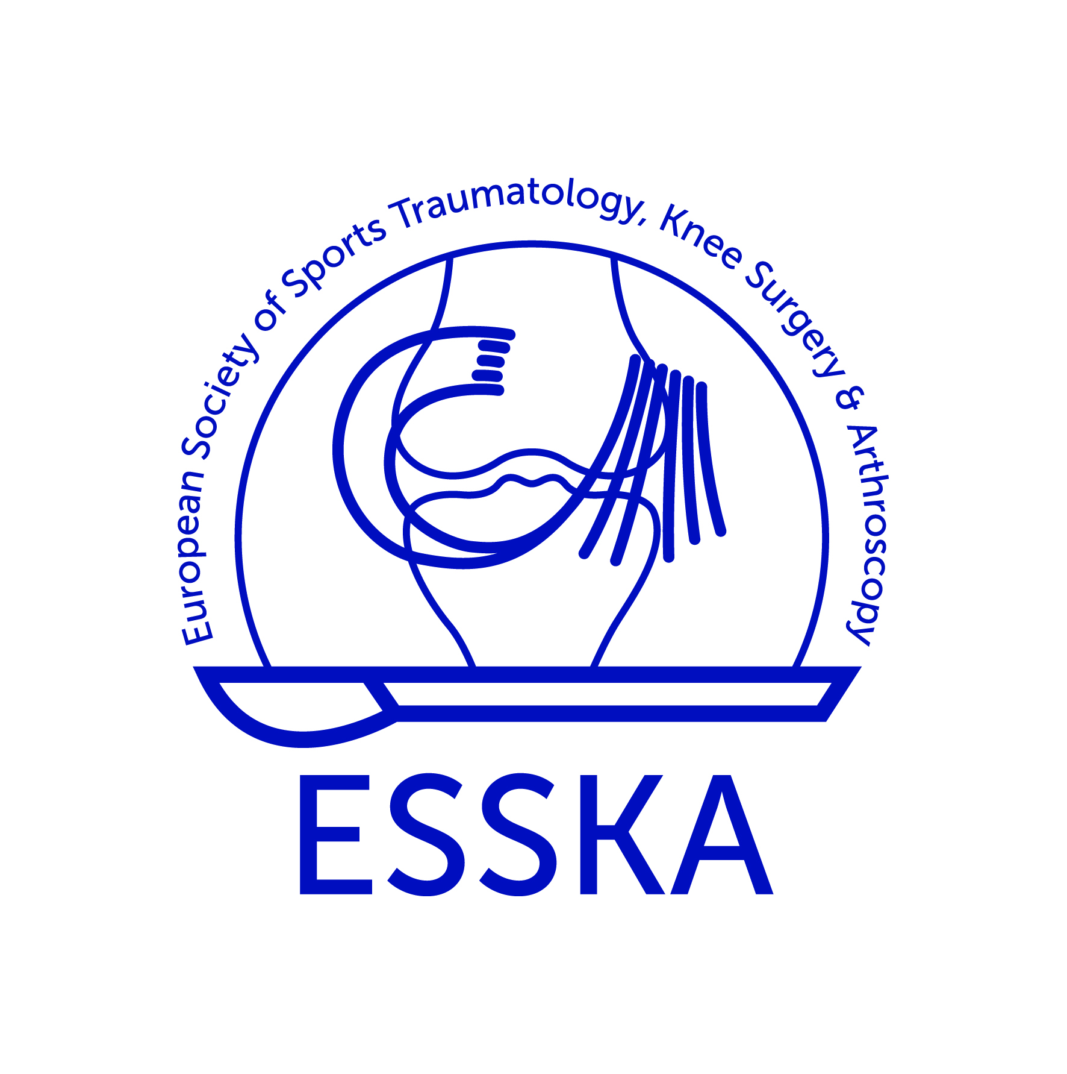

# 

# David H. DEJOUR

Medical Doctor, Orthopedic Knee Surgeon

Lyon-Ortho-Clinic LYON FRANCE

David DEJOUR is head Director of Lyon-Ortho-Clinic since 1996.

He is known worldwide for his pioneering research on patellofemoral joint, knee ACL, and Patellofemoral joint in degenerative Knee.

He has been president of ESSKA 2018-2020, he has been involved in the board of the Francophone Arthroscopy Society (SFA) and the French National society (SOFCOT) and he is past president of the Lyon School of Knee Surgery. He Received a life time award for his work in patellofemoral disorders and orthopedics, by the patellofemoral foundation.

His primary interest is knee sport’s traumatology and pain. He published the worldwide classification of Trochlear dysplasia and described several original surgical procedures for it. He published numerous scientific studies about ACL reconstruction, return to sport and muscle recovery after sport’s trauma. He wrote books on patellofemoral disorders, ACL and Knee degenerative, he is authors of numerous book chapters.

His medical center is dedicated to professional and recreational sport player in soccer, rugby, basket, handball, running teams and fighting sports. Each year Lyon-Ortho-Clinic trained fellows, residents, and visitors under his supervision. The center has a high expertise in Fast track recovery in knee surgery.

His secondary interest is the future of all these athletes with degenerative knees. He has done some research on osteotomies and partial or total knee arthroplasty to keep patients on daily active and sport’s life.

Get the full CV at : <https://www.lyon-ortho-clinic.com>